INTERNET SOFTWARE
ARCHITECTURE
Weather App Report
Individual Assessment
Name: Sumit Kumar Chaudhary
Group: L4CG4
Student ID: 2607768

Table of Contents
ABSTRACT 4
Objectives 5
Aims 5
Strengths 5
Weaknesses 6
UML DIAGRAM 7
1. Deployment Diagram: 7
2. Activity Diagram: 8
3. Sequence Diagram: 9
LOCAL STORAGE 10
Links 11
CONCLUSION 12

Table of Figures

Figure 1: Deployment Diagram 7
Figure 2: Activity Diagram 8
Figure 3: Sequence Diagram 9
Figure 4: Local Storage 10

ABSTRACT
This website is designed to display weather information of any city (temperature, wind speed, wind direction, humidity, weather condition, weather description, sunrise, sunset, date, and time). The OpenWeatherMap API is used to fetch the weather details for the selected. PHP is used as the server-side technology to handle the API requests and store weather data into the database.

When the app starts, the system loads the default city’s weather. Users can then search for any city by typing its name. When the device is online, the requested weather information is fetched, processed, stored in database, and displayed dynamically. If the device is online, the retrieved weather data is also stored into localStorage for offline. So, the user an access that particular weather data even the user is offline. This website is also successfully hosted on infinityfree which can be accessed through: Website Link

Objectives
The report analyses the advantages and disadvantages of the design of a weather application created with HTML, CSS, and JavaScript and PHP. The app offers live weather information for Selma city by default and allows user to search for other cities.

This report also evaluates how the use of PHP backend combined with client-side localStorage improves security, data handling, overall system reliability and limited offline accessibility.

Aims
This report aims to analyse the advantages and disadvantages of the app's architecture while highlighting possible enhancements to improve performance, security, scalability and user experience in the future.

Strengths
- The application is successfully hosted on InfinityFree, proving that the system works correctly in an online production-like environment.
- The application follows client-server architecture using PHP as backend, improving data handling and security.
- Weather data is fetched from API we do not need any personal sensor or local data collection.
- The OpenWeatherMap API is accessed through the server, reducing direct exposure of the API key.
- Weather data is stored in databases, allowing better data management and potential future analysis.
- Weather data is updated at regular 2 hours interval, ensuring up-to-date information.
- Users can get weather data of any city simply by searching for the city name.
- Users can see current date for the selected city.
- LocalStorage enables limited offline access to previously searched city weather data and default weather data.
- It is designed in user friendly interface.

Weaknesses
- Weather data is completely dependent on API if that certain API server is down, the entire application cannot run.
- An active internet connection is required for first-time city searches.
- As, the website is hosted online the offline data only works for local device not for everyone.
- Offline functionality is limited to cities that have already been searched and stored in localStorage.
- The application currently does not provide a user interface to view or analyze historical weather data.
- Although data is stored periodically, advanced analytics and long-term data visualization are not implemented.
- After refreshing the website, the user is shown the city details that are kept by default, not the user has searched
- The design is not responsive; it is only built for laptop devices.

UML DIAGRAM

Deployment Diagram:
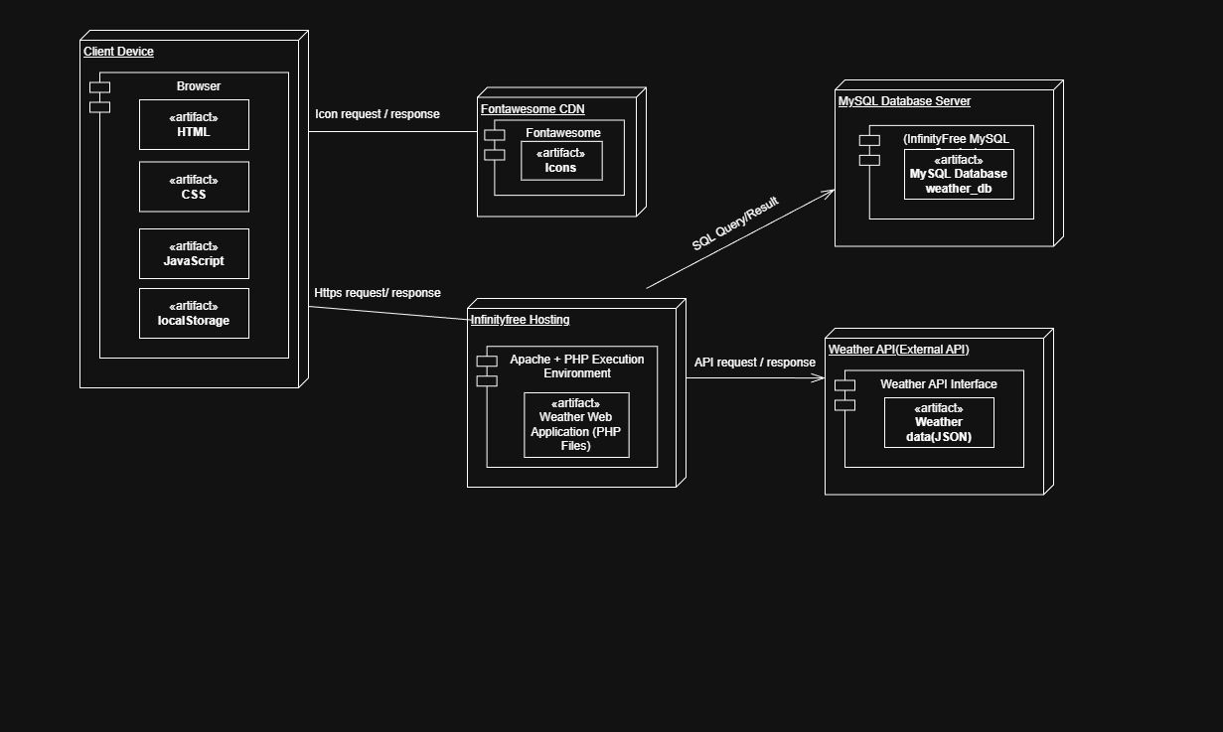
Figure 1: Deployment Diagram

Activity Diagram:
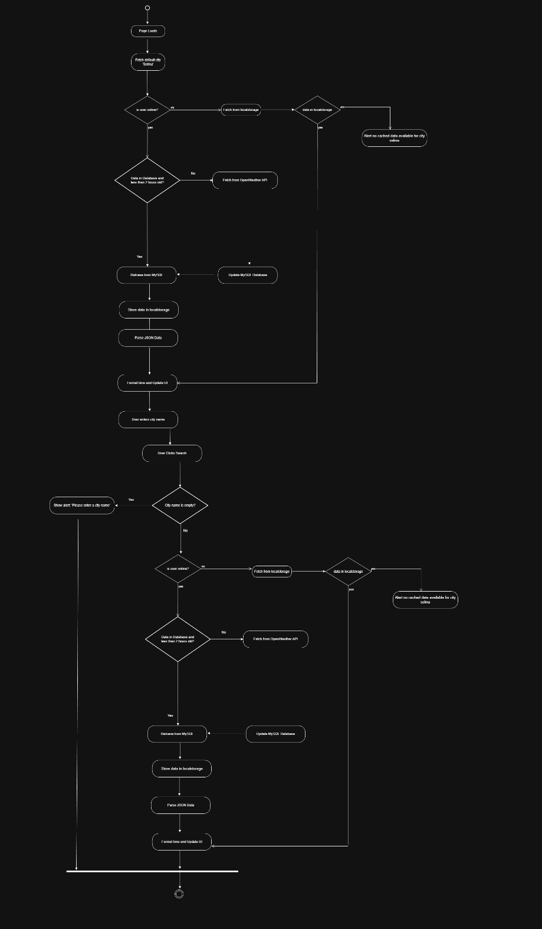
Figure 2: Activity Diagram

Sequence Diagram:
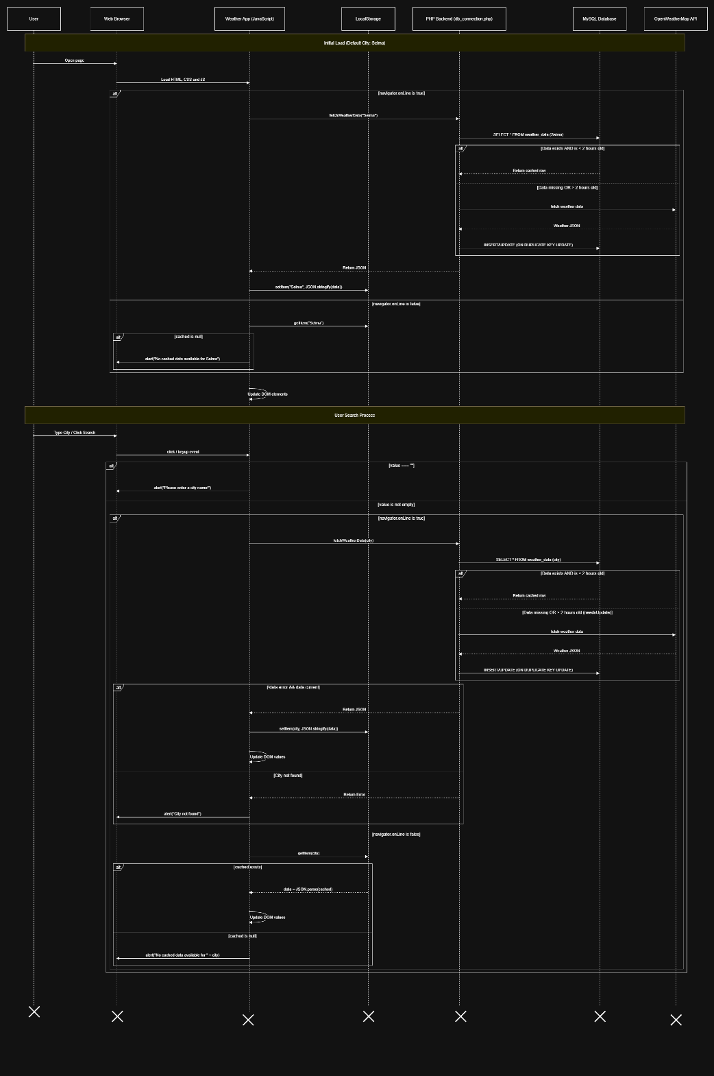
Figure 3: Sequence Diagram

LOCAL STORAGE
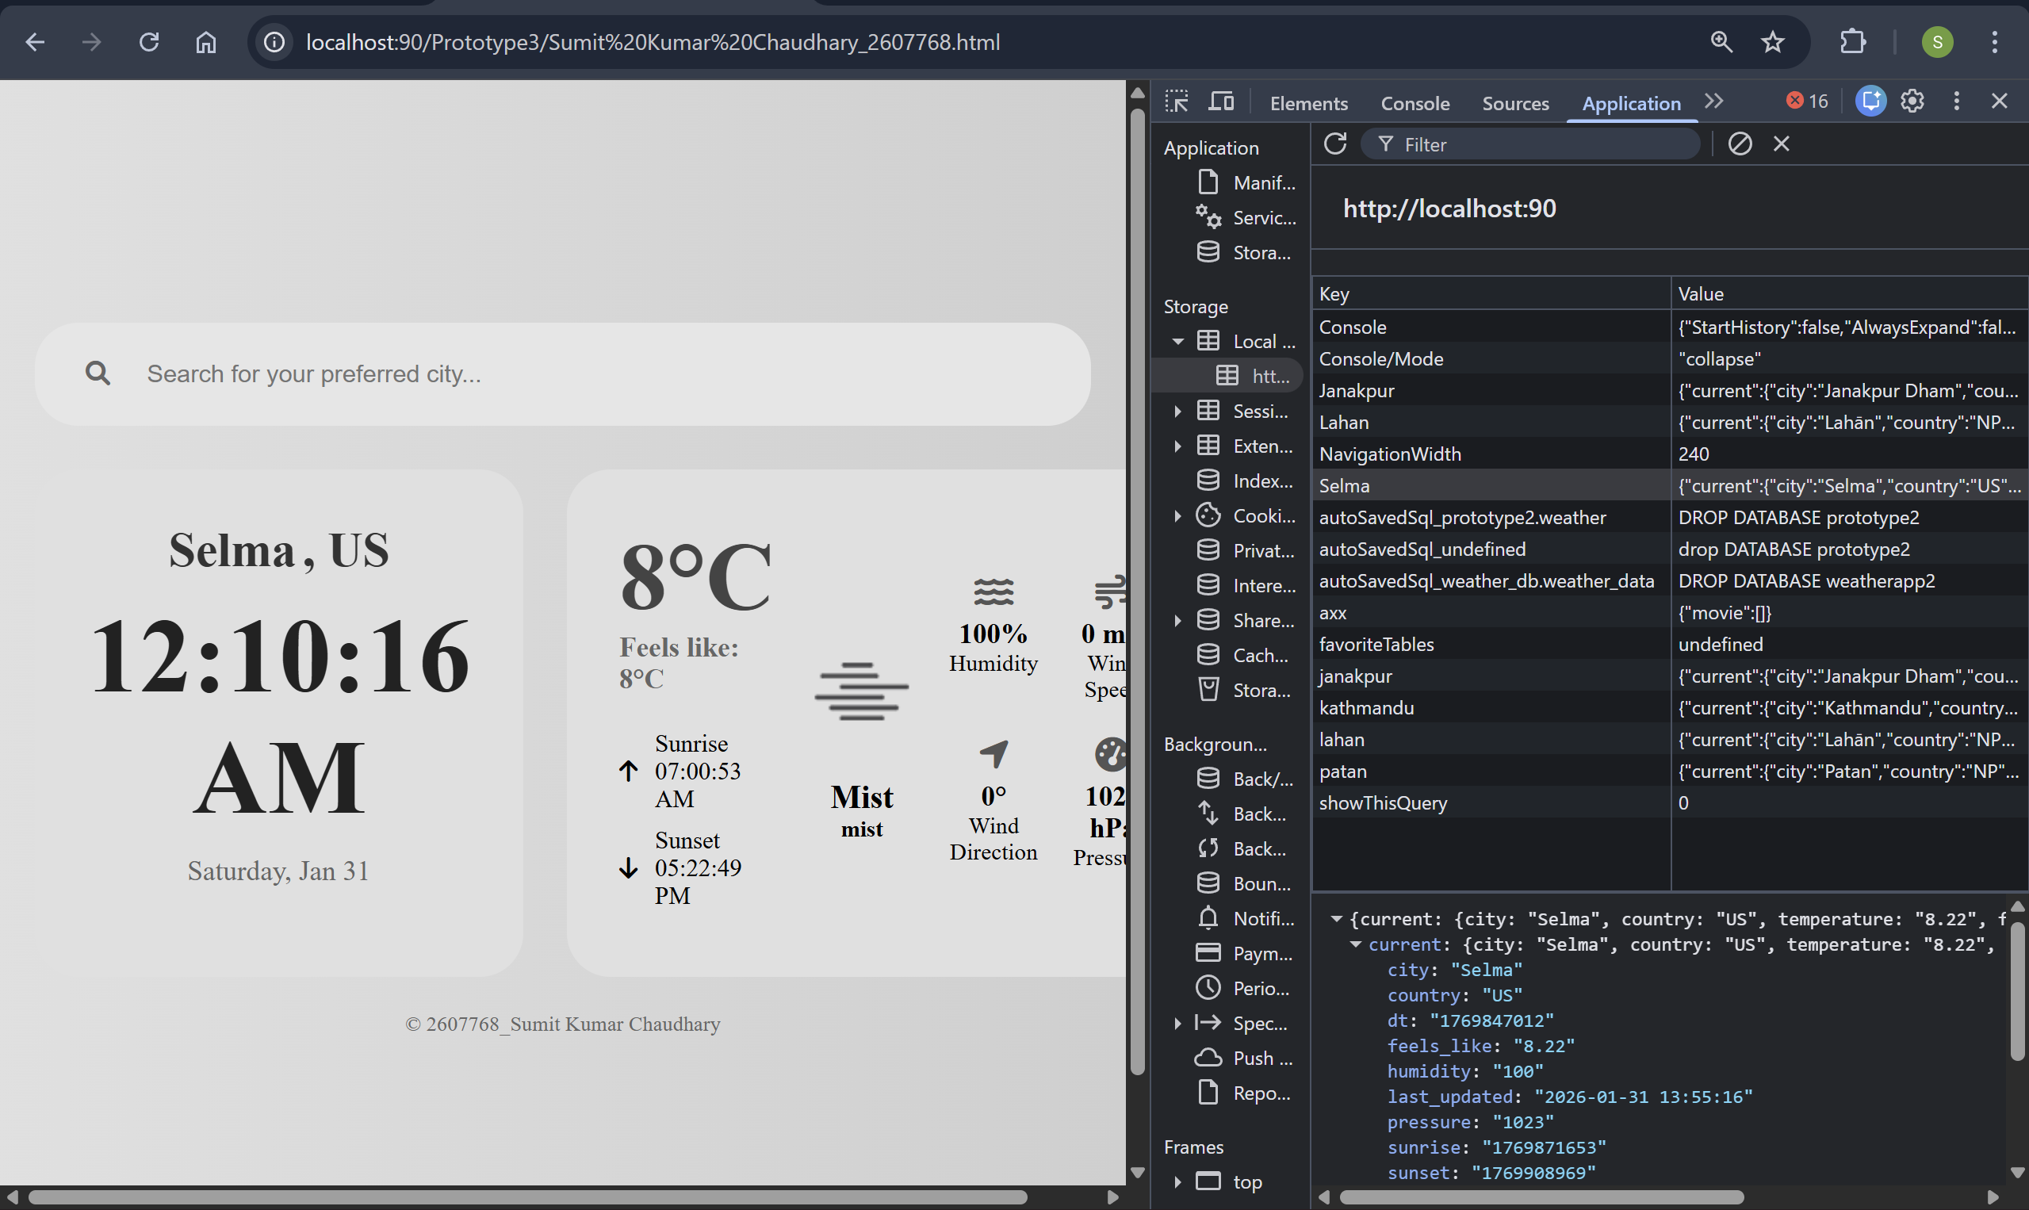
Figure 4: Local Storage

Links
Website Link: Click Here
YouTube Video Link: Click Here

\

CONCLUSION
The Weather App successfully employs a PHP backend and database to securely retrieve, store, and showcase real-time weather data. The addition of localStorage improves usability by allowing limited offline access to previously retrieved data. It offers an engaging user experience and straightforward deployment. It is also successfully hosted on InfinityFree server which can be accessed through Website link. Although it is appropriate for smaller applications, advancements such as responsive design, access to historical data, and improved analytics could enhance its strength for extended use and larger audiences.

